**Experiment 8**

**Aim:** To study the op amp as an inverting and non- inverting amplifier.

**Tools Used:**

**Theory:** Operational Amplifier commonly known as Op-Amp, is a linear electronic device having three terminals, two high impedance input and one output terminal. Op-Amp can perform multiple function when attached to different feedback combinations like resistive, capacitive or both. Generally, it is used as voltage amplifier and the output voltage of the Op-Amp is the difference between the voltages at its two input terminals.

Op-Amp shows some properties that make it an ideal amplifier, its open loop gain and input impedance is infinite (i.e., practically very high), Output impedance and offset voltage is zero (i.e., practically very low) and bandwidth is infinite (i.e., practically limited to frequency where its gain become unity).

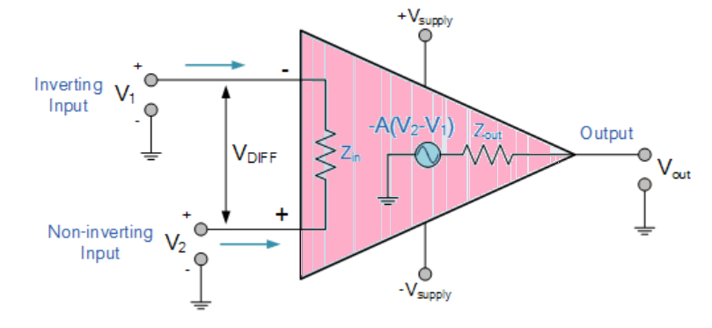

Fig. 1: Operational Amplifier

**Inverting Op-Amp:** The open loop gain (Ao) of the Om-Amp is very high which makes it very unstable, so to make it stable with a controllable gain, a feedback is applied through some external resistor (RF) from its output to inverting input terminal(i.e., also known as negative feedback) resulting in reduced gain (closed loop gain, Av). So, the voltage at inverting terminal is now the sum of the actual input and feedback voltages, and to separate both an input resistor (Ri) is introduced in the circuit. The non-inverting terminal of the Op-Amp is grounded, and the inverting terminal behaves like a virtual ground as the junction of the input and feedback signal are at the same potential.

Current can be given

$$I=\frac{V_{in}-V_{out}}{R_{in}+R_{out}}$$

or,

$$I=\frac{V_{in}-V_{2}}{R_{in}}$$

or,

$$I=\frac{V_{2}-V_{out}}{R_{F}}$$

$$I=\frac{V_{in}}{R_{in}}-\frac{V_{2}}{R_{in}}=\frac{V_{2}}{R_{F}}-\frac{V_{out}}{R_{F}}$$

So,

$$\frac{V_{in}}{R_{in}}=V_{2}×\left(\frac{1}{R_{in}}+\frac{1}{R}\right)-\frac{V_{out}}{R_{F}}$$

and as, V2=0

or,

The close loop gain (Acl) is given by :-

$$A_{cl}=\frac{V_{out}}{V_{in}}=-\frac{R_{F}}{R_{in}}$$

Output voltage (Vout) is given by :-

$$V_{out}=-\frac{R_{F}}{R_{in}}×V_{in}$$

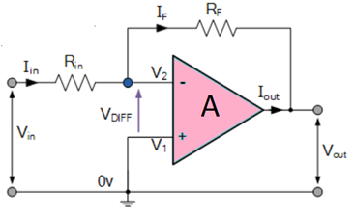  
Fig. 2: Inverting Operational Amplifier

**Non-Inverting Op-Amp:** In this configuration of Op-Amp the input signal is directly fed to the non-inverting terminal resulting in a positive gain and output voltage in phase with input as compared to inverting Op-Amp where the gain is negative and output voltage is out of phase with input , and to stabilize the circuit a negative feedback is applied through a resistor(RF) and the inverting terminal is grounded with an input resistor(R2).This inverting Op-Amp like layout the at inverting terminal creates a virtual ground at the summing point make the RF and R2 a potential divider across inverting terminal, Hence determines the gain of the circuit.

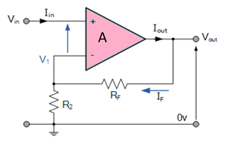

Fig. 3: Non-Inverting Operational Amplifier

Potential difference V1 can be written as

$$V_{1}=\frac{R_{2}}{\left(R_{2}+R_{F}\right)}×V_{out}$$

in ideal condition: V1=Vin

So,

and as we know Gain $A_{cl}=\frac{V_{out}}{V_{in}}$

$$A_{cl}=\frac{\left(R_{2}+R_{F}\right)}{R_{2}}=1+\frac{R_{2}}{R_{F}}$$

and Output Voltage (Vout) is given by:

$$V_{out}=\left(1+\frac{R_{F}}{R_{2}}\right)×V_{in}$$

**Wiring Diagram:**

1. Inverting Op-Amp:

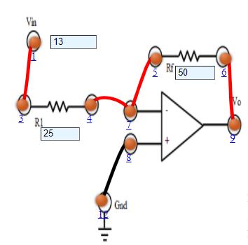

1. Non-Inverting Op-Amp:

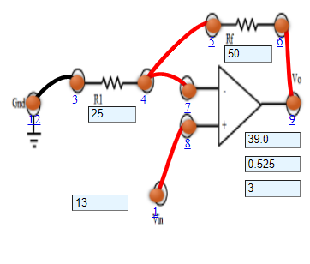

**Graph:**

1. Inverting Op-Amp:

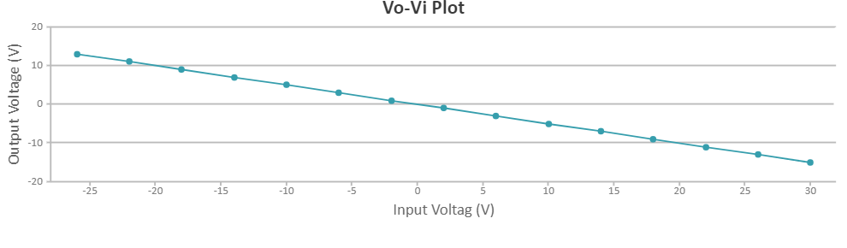

1. Non-Inverting Op-Amp:

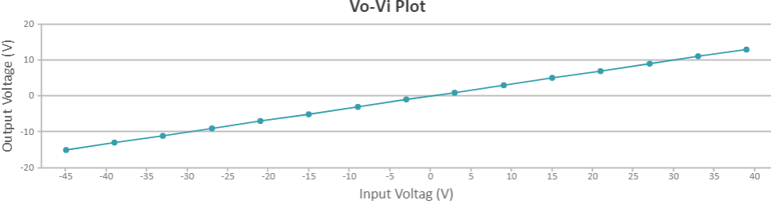

**Observations:**

1. Inverting Op-Amp:

Resistance = 25Ω

|  |  |  |  |
| --- | --- | --- | --- |
| Serial No. | Input Voltage (V) | Output Voltage (V) | Current (mA) |
| 1 | -15 | 30.0 | -0.0176 |
| 2 | -13 | 26.0 | -0.0153 |
| 3 | -11 | 22.0 | -0.0129 |
| 4 | -9 | 18.0 | -0.0106 |
| 5 | -7 | 14.0 | -0.00824 |
| 6 | -5 | 10.0 | -0.00588 |
| 7 | -3 | 6.0 | -0.00353 |
| 8 | -1 | 2.0 | -0.00118 |
| 9 | 1 | -2.0 | 0.00118 |
| 10 | 3 | -6.0 | 0.00353 |
| 11 | 5 | -10.0 | 0.00588 |
| 12 | 7 | -14.0 | 0.00824 |
| 13 | 9 | -18.0 | 0.0106 |
| 14 | 11 | -22.0 | 0.0129 |
| 15 | 13 | -26.0 | 0.0176 |

1. Non-Inverting Op-Amp:

Resistance = 25Ω

|  |  |  |  |
| --- | --- | --- | --- |
| Serial No | Input Voltage (V) | Output Voltage (V) | Current (mA) |
| 1 | -15 | -45.0 | NaN |
| 2 | -13 | -39.0 | NaN |
| 3 | -11 | -3300 | NaN |
| 4 | -9 | -27.0 | NaN |
| 5 | -7 | -21.0 | NaN |
| 6 | -5 | -15.0 | NaN |
| 7 | -3 | -9.0 | NaN |
| 8 | -1 | -3.0 | NaN |
| 9 | 1 | 3.0 | 0.00510 |
| 10 | 3 | 9.0 | 0.0153 |
| 11 | 5 | 15.0 | 0.202 |
| 12 | 7 | 21.0 | 0.283 |
| 13 | 9 | 27.0 | 0.364 |
| 14 | 11 | 33.0 | 0.444 |
| 15 | 13 | 39.0 | 0.525 |

**Results and Conclusion:** The designing and testing of inverting and non-inverting operational amplifier and its graph between voltage and the current has been plotted successfully.